**Answer the following**

1. Select CategoryName and Description from the Categories table sorted by CategoryName.

SELECT CategoryName, Description

FROM Categories

ORDER BY CategoryName ASC;

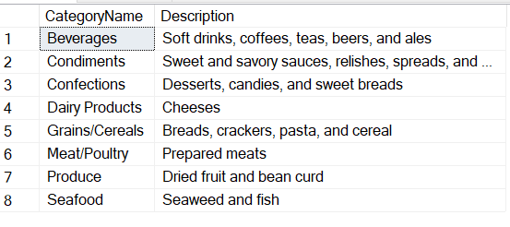

1. Select ContactName, CompanyName, ContactTitle, and Phone from the Customers table sorted by Phone

SELECT ContactName, CompanyName, ContactTitle, Phone

FROM Customers

ORDER BY Phone ;

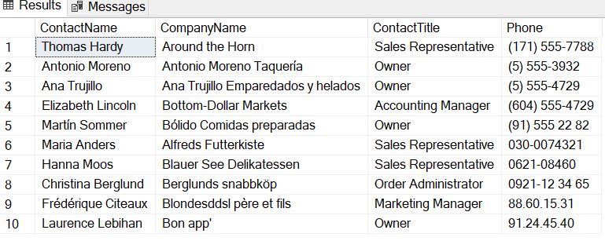

1. Display the employees' first and last names and hire dates sorted from newest to oldestemployee

SELECT FirstName, LastName, HireDate

FROM Employees

ORDER BY HireDate;

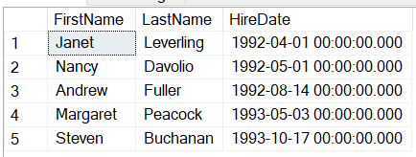

1. Create a report showing Northwind's orders sorted by Freight from most expensive to cheapest. Show OrderID, OrderDate, ShippedDate, CustomerID, and Freight.

SELECT OrderID, OrderDate, ShippedDate, CustomerID, Freight

FROM Orders

ORDER BY Freight DESC;

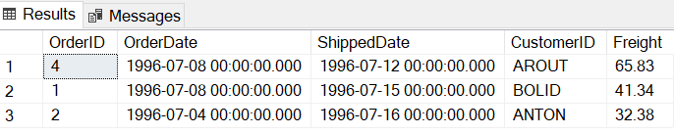

1. Select CompanyName, Fax, Phone, HomePage and Country from the Suppliers table sorted by Country in descending order and then by CompanyName in ascending order.

SELECT CompanyName, Fax, Phone, HomePage, Country

FROM Suppliers

ORDER BY Country DESC, CompanyName ASC ;

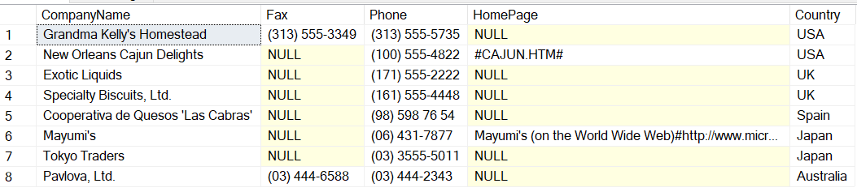

1. Display all the company names and contact names of Northwind's customers inBuenos Aires.

SELECT CompanyName, ContactName

FROM Customers

WHERE City = 'Buenos Aires';

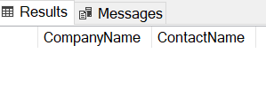

1. Display the product name, unit price and quantity per unit of all products that are out of stock.

SELECT ProductName, UnitPrice, QuantityPerUnit

FROM Products

WHERE UnitsInStock = 0;

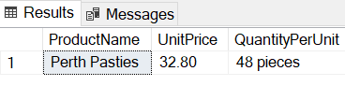

1. Display the order date, shipped date, customer id, and freight of all orders placed on May 19, 1997.

SELECT OrderDate, ShippedDate, CustomerID, Freight

FROM Orders

WHERE OrderDate = '1997-05-19';

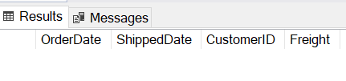

1. Display the first name, last name, and country of all employees not in the United States.

SELECT FirstName, LastName, Country

FROM Employees

WHERE Country <>'USA';

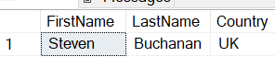

1. Display the employee id, order id, customer id, required date, and shipped date of all orders that were shipped later than they were required.

SELECT EmployeeID, OrderID, CustomerID, RequiredDate, ShippedDate

FROM Orders

WHERE ShippedDate > RequiredDate;

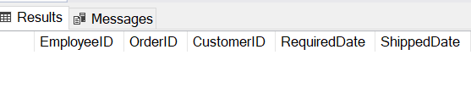

1. Display the city, company name, and contact name of all customers who are in cities that begin with "A" or "B."

SELECT City, CompanyName, ContactName

FROM Customers

WHERE City LIKE 'A%' OR City LIKE 'B%';

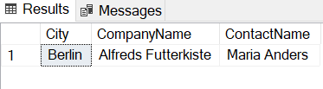

1. Display all orders that have a freight cost of more than $500.00.

SELECT *

FROM Orders

WHERE Freight > 50;



1. Display the product name, units in stock, units on order, and reorder level of all products that are up for reorder

SELECT ProductName, UnitsInStock, UnitsOnOrder, ReorderLevel

FROM Products

WHERE UnitsInStock <= ReorderLevel;

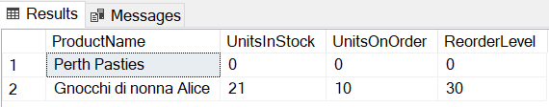

1. Display the company name, contact name and fax number of all customers that have a fax number.

SELECT CompanyName, ContactName, Fax

FROM Customers

WHERE Fax IS NOT NULL;

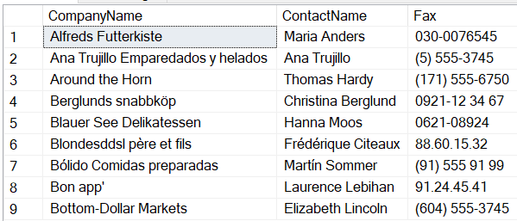

1. Display the first and last name of all employees who do not report to anybody

SELECT FirstName, LastName

FROM Employees

WHERE ReportsTo IS NULL;

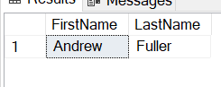

1. Display the company name, contact name and fax number of all customers that have a fax number. Sort by company name.

SELECT CompanyName, ContactName, Fax

FROM Customers

WHERE Fax IS NOT NULL

ORDER BY CompanyName;

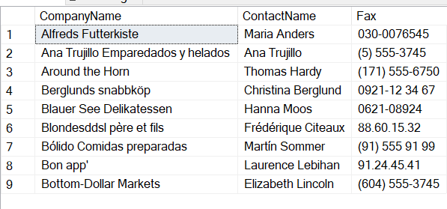

1. Display the city, company name, and contact name of all customers who are in cities that begin with "A" or "B." Sort by contact name in descending order

SELECT City, CompanyName, ContactName

FROM Customers

WHERE City LIKE 'A%' OR City LIKE 'B%'

ORDER BY ContactName DESC;



1. Display the first and last names and birth date of all employees born in the 1950s.

SELECT FirstName, LastName, BirthDate

FROM Employees

WHERE BirthDate BETWEEN '1950-01-01' AND '1959-12-31';

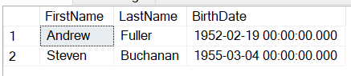

1. Display the product name and supplier id for all products supplied by Exotic Liquids, Grandma Kelly's Homestead, and Tokyo Traders.

Hint

you will need to first do a separate SELECT on the Suppliers table to find the supplier ids of these three companies.

SELECT ProductName, SupplierID

FROM Products

WHERE SupplierID IN (

SELECT SupplierID

FROM Suppliers

WHERE CompanyName IN ('Exotic Liquids', 'Grandma Kelly''s Homestead', 'Tokyo Traders')

);

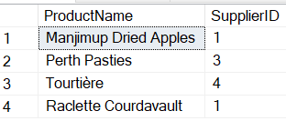

1. Display the shipping postal code, order id, and order date for all orders with a ship postal code beginning with "02389".

SELECT ShipPostalCode, OrderID, OrderDate

FROM Orders

WHERE ShipPostalCode LIKE '6900%';



1. Display the contact name and title and the company name for all customers whose contact title does not contain the word "Sales".

SELECT ContactName, ContactTitle, CompanyName

FROM Customers

WHERE ContactTitle NOT LIKE '%Sales%';

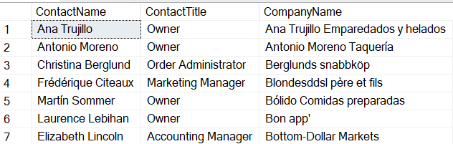

1. Display the first and last names and cities of employees from cities other than Seattle in the state of Washington.

SELECT FirstName, LastName, City

FROM Employees

WHERE City <> 'Seattle';

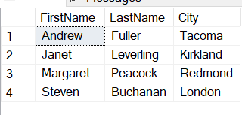

1. Display the company name, contact title, city and country of all customers in Mexico or in any city in Spain except Madrid

SELECT CompanyName, ContactTitle, City, Country

FROM Customers

WHERE Country = 'Mexico'

OR (Country = 'Spain' AND City <> 'Madrid');

